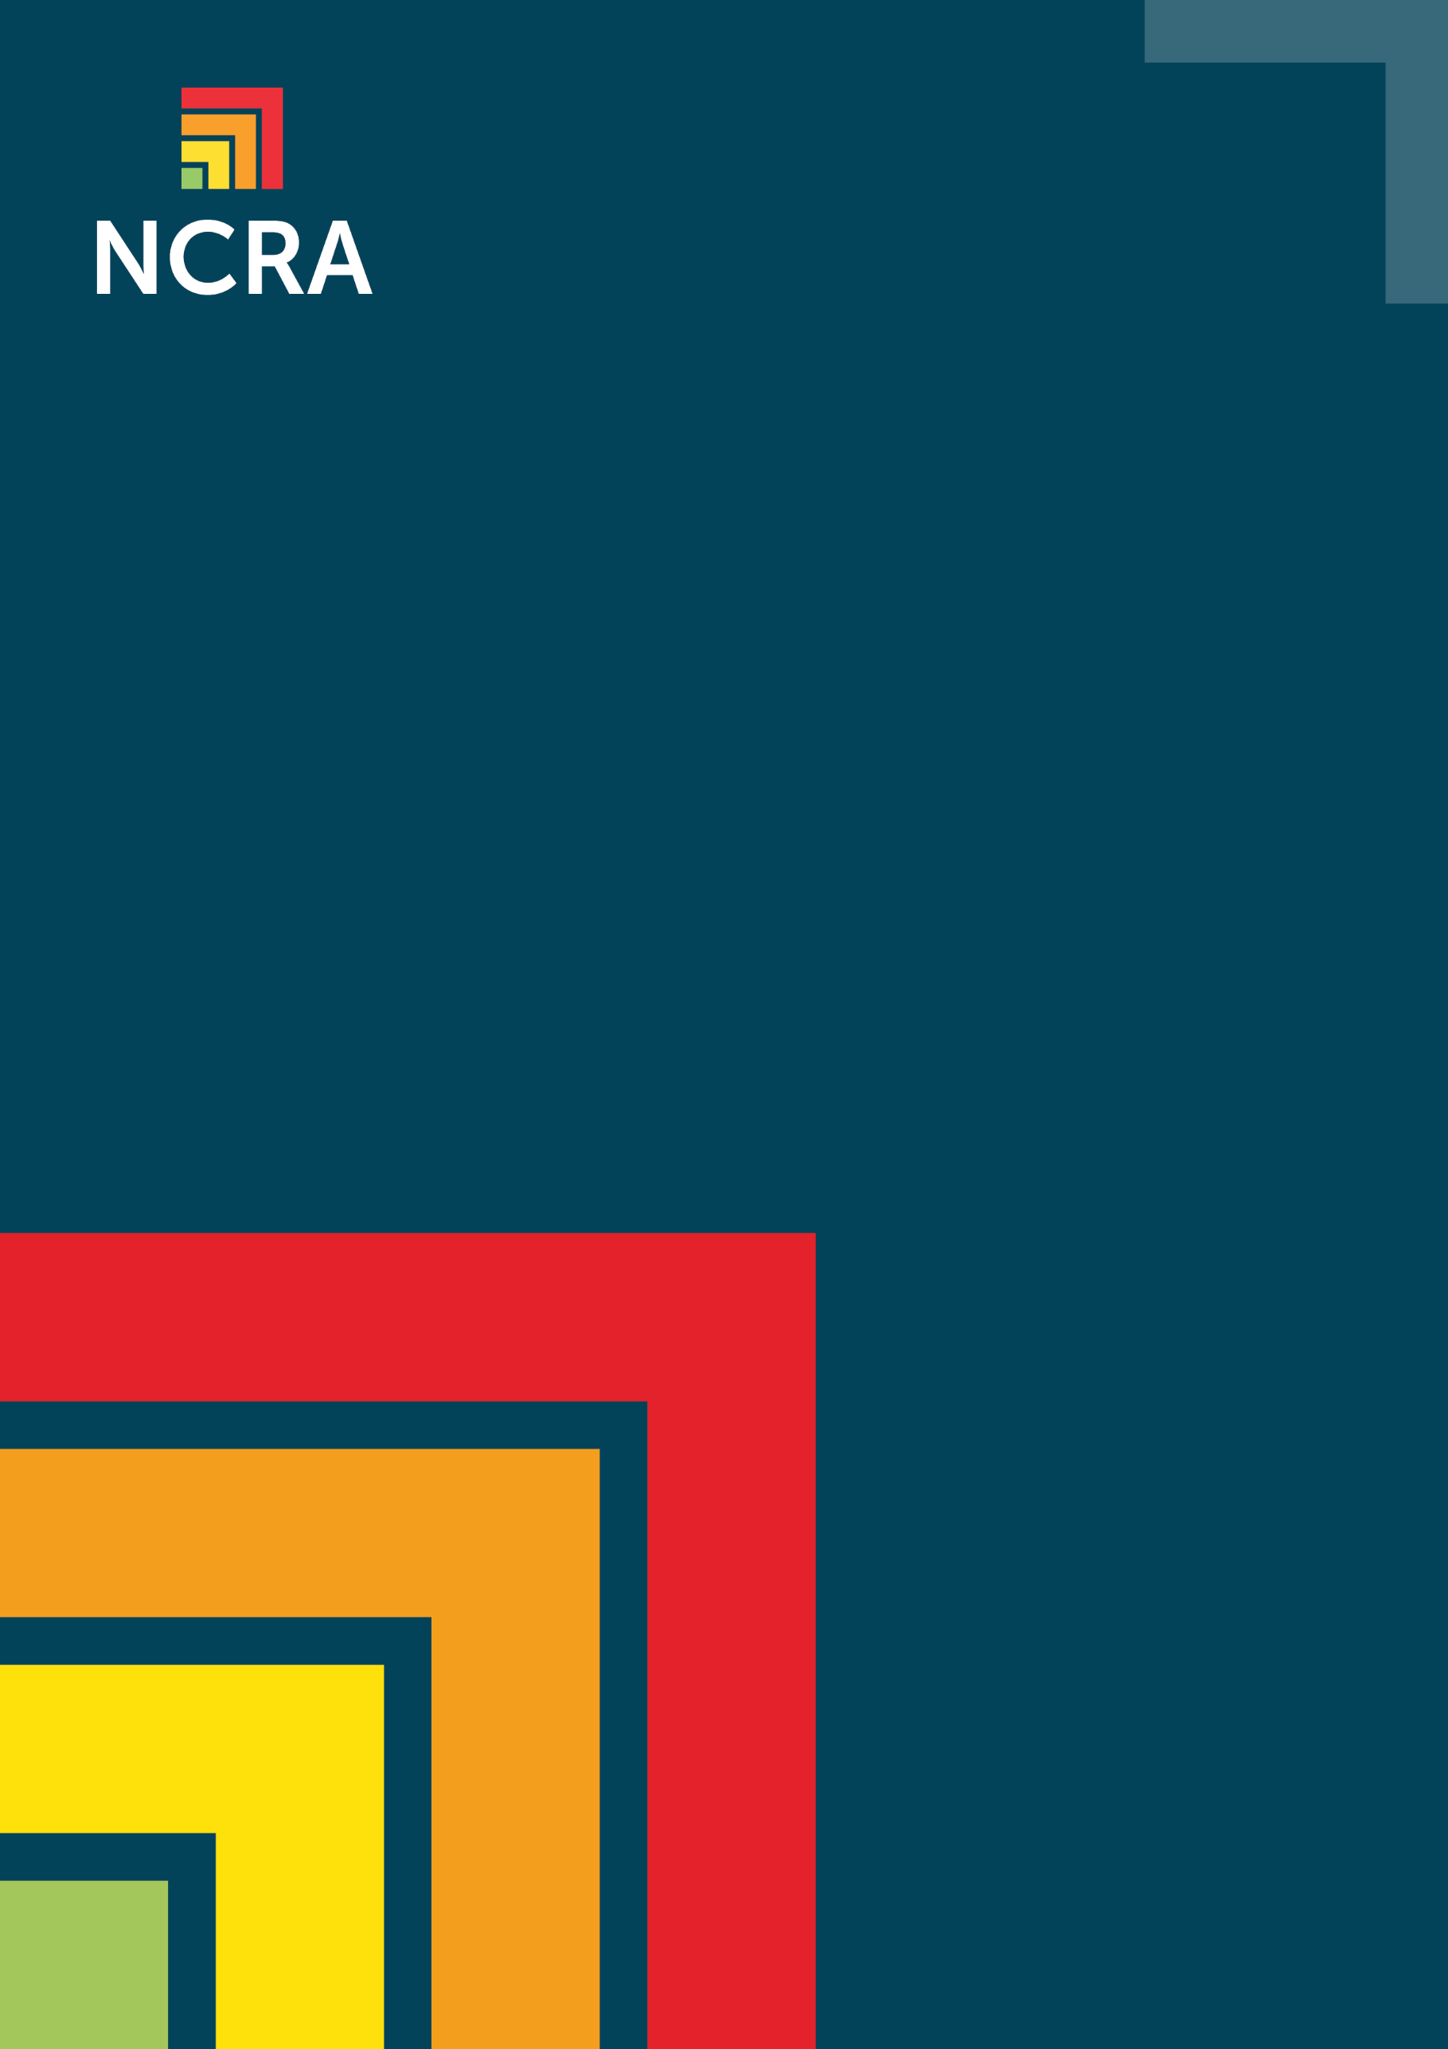

Constructed examples of worst case scenarios

Constructed examples of worse case scenarios for various systems

Banking Org: money service system

- As a bank we care massively about the Integrity and Confidentiality of the money service system. It is a prized target for advanced cyber criminals, where new malware could defeat our defences. This could be used to extract millions of dollars, while pinning the blame on our customers.

Telco Org: Core Network system

- Our core telco network is used by 100Ks of people every minute for business and personal needs, and they rely on it having high integrity and very high availability. We worry most about state actors using malware to reduce the availability of the network and ‘force’ people onto competing networks.

Energy Org: SCADA control system

- Our SCADA system controls the electrical generating system for the whole country and must be highly available. We are most worried about our staff (Insiders) misconfiguring the system (accidents), as this could stop us matching supply with demand, or could damage the physical and expensive components of the electricity system.

Government Org: Website system

- Our tax collection website is the main portal for business tax collection and integrity and confidentiality are essential. We are most worried about cyber criminals and state actors trying to undermine the system using phishing attacks to allow malware in.

